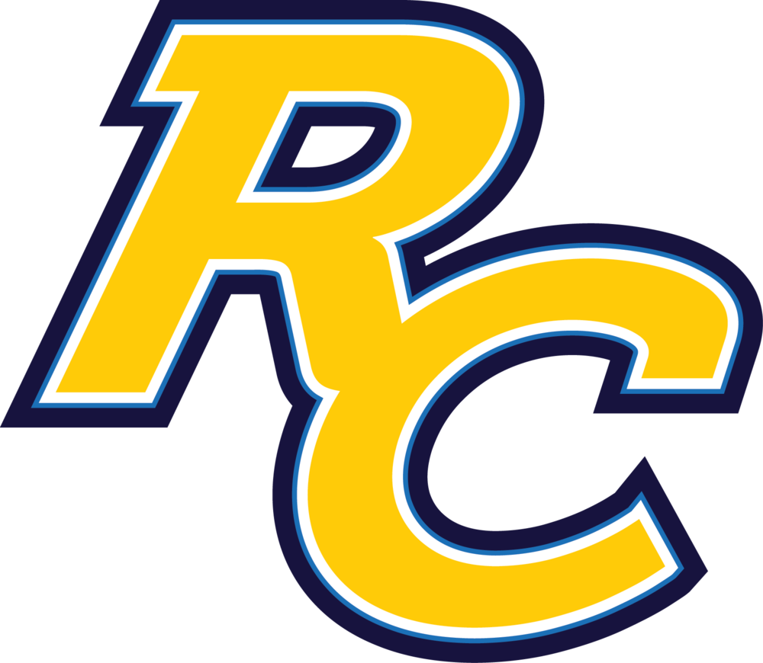
Rancho Christian School
31300 Rancho Community Way, Temecula, CA 92592
Phone: (951) 303-1408
http://www.ranchochristian.org/

General Information | The school is meant to be challenging for students in comprehensive aspects including personal, spiritual, academics, socialization and physical health. They try to dig out the biggest potential within a student by various training. Course load is rigid and challenging. School teachers hold the belief that education should center around students. Every student is unique with their different talents, interests, background and capabilities.  School is adequate in all kinds of resources from physical equipment to online academic resources. Different facilities cater to students’ needs. All teachers and staff must go through background check in order to provide a safe school environment for students.

About the School

Year Founded | 1981 | Religion | Christian
School Type | College Prep, day school | Grades | PreK-12
Student body | Co-Ed | Uniforms | Must wear school uniforms most of the time
Number of Students | 941 | International Students | 8 %
Class Size | 20 | ESL | Yes
Area | Located in Temecula, California, which is known for its natural beauty, rich history, championship golf courses, and award-winning wineries, nestled in 3,000 acres of picturesque wine country. | Student: Teacher Ratio | 15:1
 |  | Facility | Classrooms, robotics workshop, STEM center, gymnasium, science lab, art studio, computer lab, playground, school chapel
Academics

College Acceptance Rate | 100%
Average SAT Scores | 1100
Honor Courses: | Not offered
AP Courses: 10 | AP Calculus AB; AP Calculus BC; AP English Literature; AP European History; AP US History; AP Biology; AP Chemistry; AP Physics; AP Spanish; AP Computer Science

Extra-Curricular

Clubs: | Art Club, Chess Club, Chinese Culture Club, Robotics, Arts and Music Programs:  Theater, Worship Band and More...
Sports: 12 | Golf, Tennis, Football, Volleyball, Cross-country, Cheer, Dance, Basketball, Soccer, Track & Field, Baseball, Softball

College Acceptance List

Recent College Acceptances: | Berklee College of Music; Boston University; California State Polytechnic University (all campuses); Stanford University; Stony Brook University; Syracuse University; University of Arizona; University of California (all campuses); University of Colorado – Boulder; University of Connecticut; University of Houston; University of Illinois at Urbana-Champaign; University of Maryland - College Park; University of Southern California; University of Texas at Austin; University of Washington; Washington State University; Wheaton College; Whittier College; Whitworth University and more

Application

Admission Requirements | - Student’s full-face view photo (digital)  - Passport copy  - Visa and I-20 copy (students already studying in the US)  - iTEP or TOEFL Score  - Bank Letter/Certificate of Balance  - Student Questionnaire and Essay  - Transcript (Original and translated copy)  - Immunization record  - Designated Guardian Form  - Skype interviewed required (reading and spontaneous writing)

